**Week 4 – Report**

Name – Jissy Jayaprakash

**Connect Online stream of data with OpenCV and Creating Boundary box with example**

* I had connected OpenCV with online Stream. I used a YouTube video link and connected to that data stream.
* After running the code, the frames are created in the system.
* Refer the screenshot, here I provided the output.

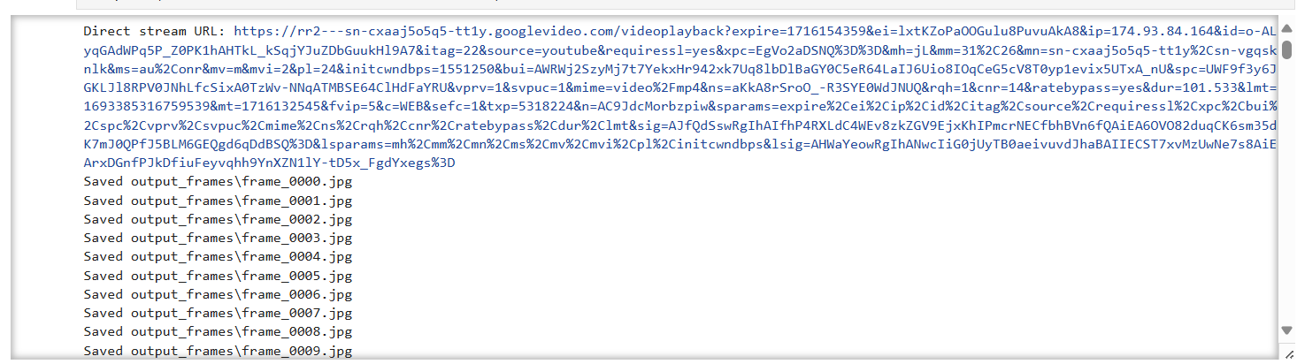

* Then I studied to create Boundary boxes. With an example I had done a code. To insert boundary box in the image.
* Refer the screenshot, here I provided the output.

